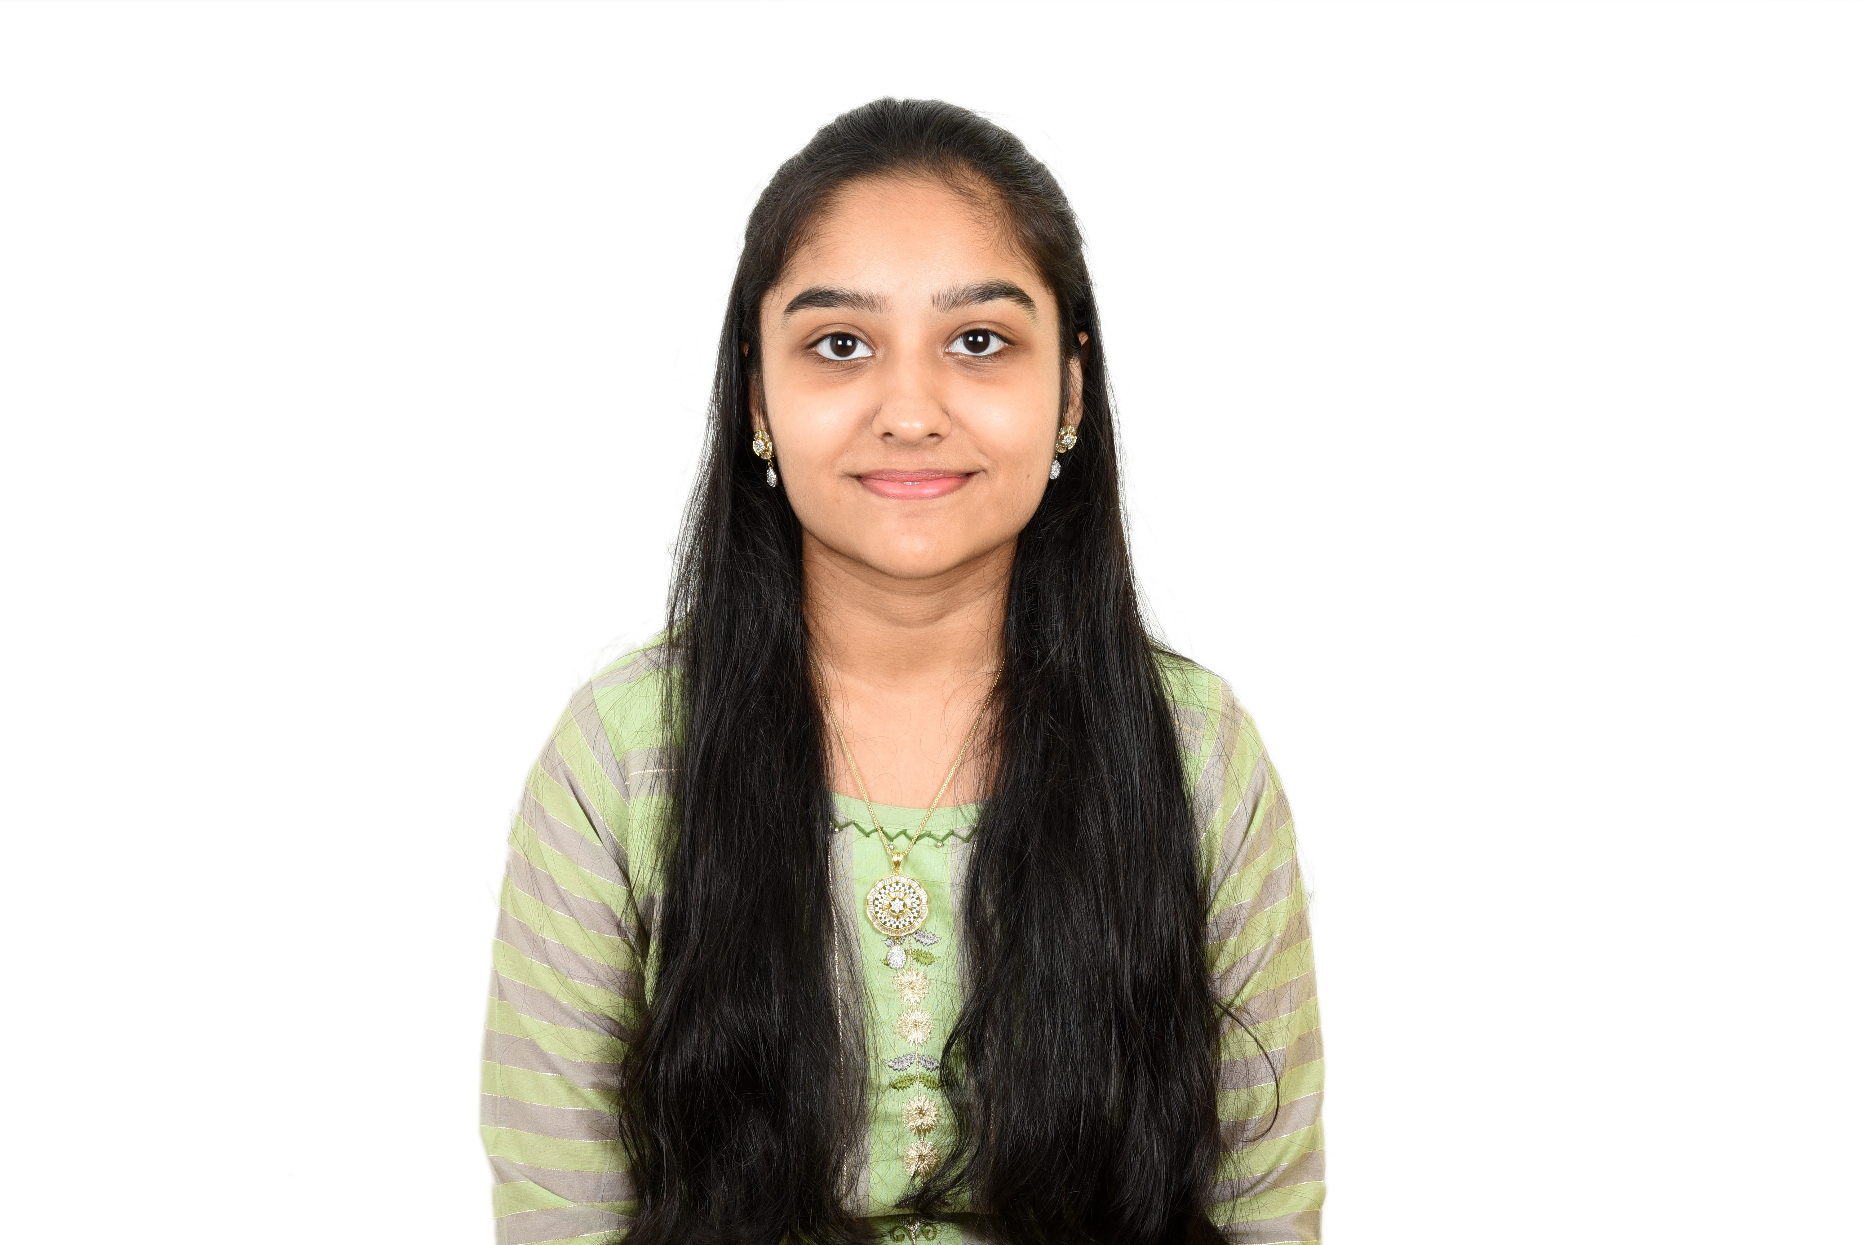 **Parishri Rakesh Shah ** +91-8692992399

Data Science and Artificial Intelligence  [22bds043@iiitdwd.ac.in](mailto:22bds043@iiitdwd.ac.in)

B Tech  [parishrishah24@gmail.com](mailto:parishrishah24@gmail.com) T Indian Institute Of Information Technology, Dharwad  [GitHub Profile](https://github.com/Parishri07)

[My Portfolio](https://parishri-portfolio.netlify.app/)  [LinkedIn Profile](https://www.linkedin.com/in/parishri-shah-0786a9263/)

# Technical Skills and Interests

**Languages**: C, C++, Java, Python

**Developer Tools**: HTML, CSS, JavaScript, Node.js, Git and GitHub, VS code

**Frameworks**: Express.js

**Areas of Interest**: Web Development

# Personal Projects

* **To do list App** *Nov’ 23*

*The To do list app enables to add work and make our own to do list.*

* + Tools technologies used: Node.js, Express.js, HTML, CSS, JavaScript
  + Developed a to do list app which keeps note of all our works to be done. Using visually appealing interface, display the list of work to be done.
  + Project URL: [To-do-list](https://github.com/Parishri07/To-do-list-app.git)
* **Web Based Games** *June’ 23*

*Developed a web platform with 4 interactive games: Tic Tac Toe, Drum Kit, Dice Challenge, Simon Game*

* + Tools technologies used: HTML, CSS, JavaScript
  + Utilized modern web technologies to create visually appealing interfaces, engaging gameplay mechanics, and scor- ing systems. Proficient in web development, game programming, audio integration, and user interface design.

Demonstrated skills in creating intuitive experiences and implementing score tracking and progression

* + Project URL: [Simon Game](https://my-simon-game-challenge.netlify.app/) [Drum Kit](https://my-drum-kit-game.netlify.app/) [Dice Challenge](https://my-dice-challenge.netlify.app/)
* **Decathlon UI** *June’ 23*

*Developed a responsive web application emulating the Decathlon website*

* + Tools technologies used: HTML, CSS, JavaScript
  + Utilized modern front-end frameworks for improved code organization and maintainability. Demonstrated profi- ciency in front-end development principles and responsive design.
  + Project URL: [Decathlon UI](https://decathlon-ui.netlify.app/)

# Certificates

* Google Cloud Computing Foundations & Generative AI*Sept‘23*

Courses:- Cloud Computing Fundamentals*,* Infrastructure in Google Cloud, Networking & Security in Google Cloud, Data, ML, and AI in Google Cloud, Create and Manage Cloud Resources, Perform Foundational Infrastructure Tasks in Google Cloud, Build and Secure Networks in Google Cloud and Perform Foundational Data, ML, and AI Tasks in Google Cloud

# EDucation

* **Indian Institute of Information Technology, Dharwad** *Dec ’22 – Aug ‘26 Data Science and Artificial Intelligence* CGPA: 8.95
* **Prakash College of Commerce and Science** *2020-2022*

*Board of Intermediate Education, State* Percentage:83

* **Thakur International School Mumbai** *2007-2020*

*Board of Secondary Education, ICSE* Percentage: 95.4

# Positions of responsibility

* **Technical Team Member,** IRIS Club(Robotics club IIIT DWD) *April’23 - Present*

# Achievements

* **Third prize for Vanilla JS Library Making Competition**

College level competition for making a library using Vanilla JS to create, display and hide modal popups.